**New manuscript workflow process (Receptionist/Secretary)**

This detailed instruction document is used for the Receptionist/Secretary position at APC and will detail exactly how that employee will go about starting the new manuscript process. This process will most often start when a new manuscript is sent to the dedicated email for APC and then will be transferred to the correct location by the Receptionist/Secretary. All information in this document will show exactly where and how this process should be done and any information that is unknown is located in previous documents such as the Technical description of APC's workflow process.

**Step-by-step Instructions**

1. Incoming email is sent to APC's specific email account for manuscripts with manuscript attached to it and authors personal information.
2. As the main person to have access to said email account (Receptionist/Secretary) will get a notification from there office computer that a new email has arrived.
3. After seeing this notification, the email will be opened and read over in its entirety by (Receptionist/Secretary).



1. While reading over this new email (Receptionist/Secretary) needs to check for several key elements.
   1. author full name
   2. authors contact information.
   3. attached manuscript.
   4. any other author demands and or details that are important to publishing.
2. After reading over this information (Receptionist/Secretary) will forward said email to (Account Clerk) who will create a new ledger card.
   1. creation of new ledger card with "new manuscript" box checked will also create new manuscript folder in manuscript system with relevant information already filled in.
3. While ledger card is being created (Receptionist/Secretary) create temporary folder on their desktop computer.

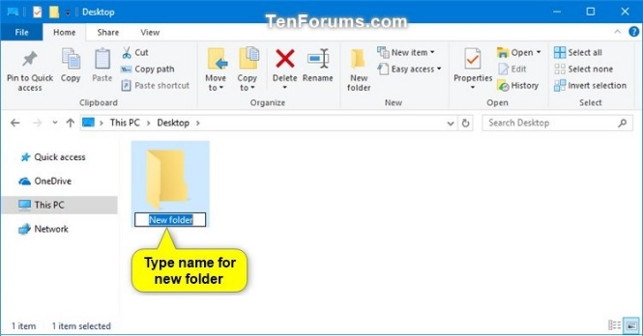

1. Then (Receptionist/Secretary) will move all information from the email detailed above into the temporary desktop folder.
   1. this folder will follow the name convention of author last name then first name then title of manuscript.
2. Then (Account Clerk) notifies (Receptionist/Secretary) that ledger card is created.
3. (Receptionist/Secretary) will move that temporary folder into the manuscript database through the manuscript system.
   1. This is done by first accessing manuscript system through desktop application, and logging in.

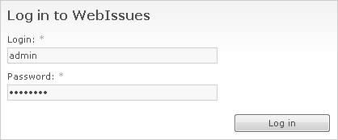

* 1. Finding new manuscript for specific author and manuscript by using search bar in manuscript system.

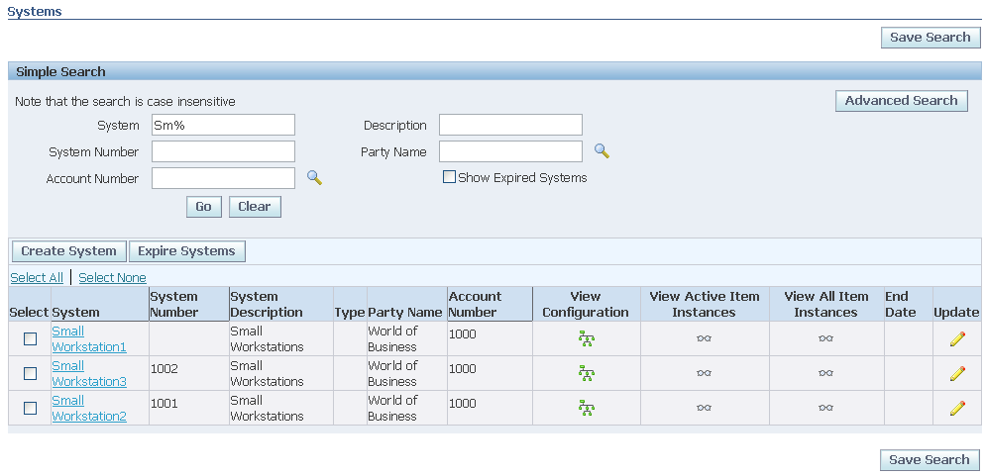

* 1. Then moving folder using simple drag and drop feature where you would drag the temporary desktop folder into the correct manuscript folder in the manuscript system.

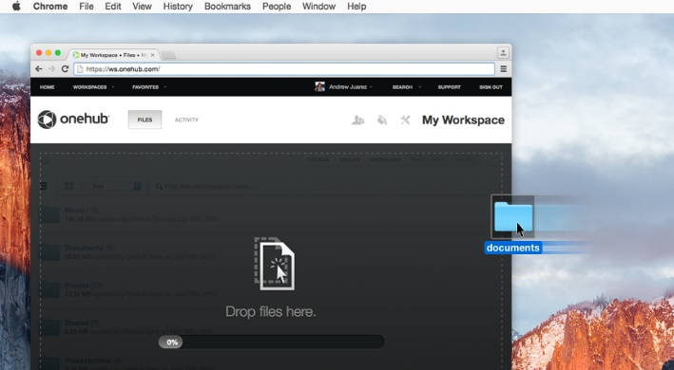

1. (Receptionist/Secretary) then goes to publishing schedule program to confirm new manuscript information has been moved.
   1. This is done by first accessing publishing schedule program on desktop, and logging in.
   2. Then finding specific author and manuscript by using search bar in publishing schedule program.
   3. After accessing said schedule (Receptionist/Secretary) will check that a new manuscript folder has been created.

**Closing statements**

This process will explain how the Receptionist/Secretary should carry out this task and if done properly will fulfil the needs in the new APC workflow process. If problems arise with system connections when doing said process or loss of information there can be a serious workflow problem and will have to be dealt with accordingly by the IT department.

In summary this document details exactly how a Receptionist/Secretary at APC will complete the creation, filing, and check of new and incoming manuscripts. All technical training for using the new APC system such as the manuscript system are not detailed in this document and will be dealt with separately. If Receptionist/Secretary needs this knowledge before reading this document, please review the new systems document that will explain exactly what and how to use the new systems. This document would be entitled "New APC systems" and then the subtitles of each individual system that you might need to review.